Задача 10. Найти производную.
10.1. 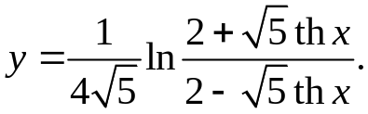
y'= 1 *2-√5thx*√5/ch²x*(2-√5thx)+ √5/ch²x*(2+√5thx) =
4√5 2+√5thx (2-√5thx)²
= 1 _
ch²x(2-√5thx)
10.2. 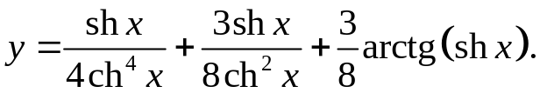
y'= ch⁵x-4ch^{3x}sh²x + 3ch³x-6chxsh²x + 3chx = 1 + 3-3sh²x + 3 _
4ch⁸x 8ch⁴x 8(1+sh²x) 4ch⁵x 8ch³x 8chx
10.3. 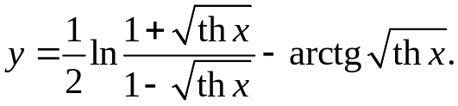
1-√(thx) + 1+√(thx) _
y'= 1/2* 1-√(thx) * 2√(thx)ch²x 2√(thx)ch²x _ 1 =
1+√(thx) (1-√(thx))² 2√(thx)ch²x
= √thx _
(1-th²x)(ch²x)

10.4. 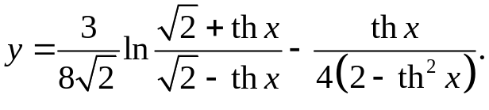
√2-thx + √2+thx 2-th²x + 2th²x
y'= 3 *√2-thx * ch²x ch²x _ ch²x ch²x =
8√2 √2+thx (√2-thx)² 4(2-th²x)²
= 1 _
2ch²x(2-th²x)²
10.5. 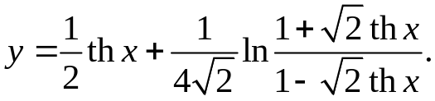
y'= 1 + 1-√2thx * √2(1-√2thx+1+√2thx) =
2ch²x 4√2(1+√2thx) ch²x(1-√2thx)²
= 1-th²x _
ch²x(1-√2thx)²
10.6. 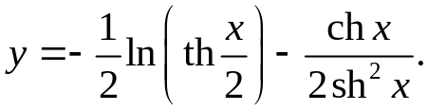
y'= _ 1 _ sh³x-2shxch²x = 2ch³x+2chx-sh²x
4thxch²x 2sh⁴x 4sh³xchx
10.7. 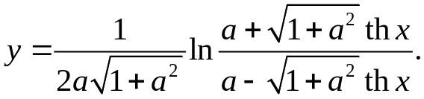

y'= a-√(1+a²)thx * √(1+a²)thx(a-√(1+a²)thx+a+√(1+a²)thx) =
2a√(1+a²)(a+√(1+a²)thx) (a-√(1+a²)thx)²
= thx = thx = thx _
(a²-(1+a²)th²x)ch²x a²ch²x-(1+a²)sh²x a²-sh²x
10.8. 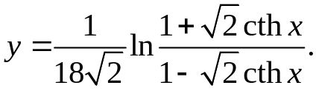
y'= 1-√2cthx * √2(-1+√2cthx+1+√2cthx) = √2cthx =
18√2(1+√2cthx) sh²x(1-√2cthx)² 9sh²x(1-√2cthx)
= -√2cthx _
9(1+ch²x)
10.9. 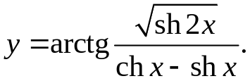
y'= 1 * ch2x/√(sh2x)-√(sh2x)(shx-chx) =
1+sh2x/(shx-chx)² chx-shx
= (chx-shx)(ch2x-sh2x(shx-chx))
√(sh2x)(ch²x+sh²x)
10.10. 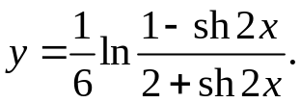
y'= 2+sh2x * -ch2x(2+sh2x)-ch2x(1-sh2x) = ch2x _
6(1-sh2x) (2+sh2x)² 12-6sh2x-sh²2x
10.11. 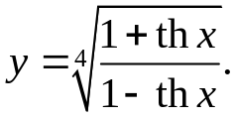
y'= ⁴√(1-thx)³ * 1-thx+1+thx = 1 _
4⁴√(1+thx)³ ch²x(1-thx) 4ch²x√(1+thx) ⁴√(1-th²x)
10.12. 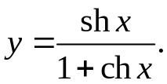
y'= chx(1+chx)-sh²x = 1 _
(1+chx)² 1+chx
10.13. 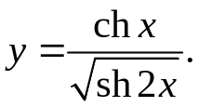
y'= shx√(sh2x)-chxch2x/√(sh2x) = shx-chxcth2x
sh2x
10.14. 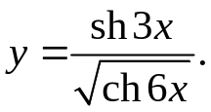
y'= 3ch3x√(ch6x)-3sh6xsh3x/√(ch6x) = 3sh3x-3th6xsh3x
ch6x
10.15. 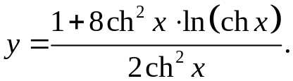

y'= 16shxch³x*ln(chx)+8ch³xshx-16ch³xshxln(chx) = 4thx
2ch⁴x
10.16. 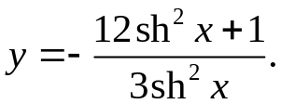
y'= 2shxchx(12sh²x+1)-24sh³xchx = 4chx
3sh⁴x 3sh³x
10.17. 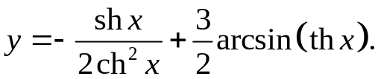
y'= 2chxsh²x-ch³x + 3 = shx-1 + 3 _
2ch⁴x ch²x√(1-th²x) 2ch³x ch²x√(1-th²x)
10.18. 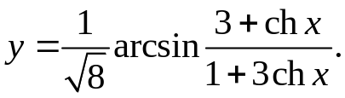
y'= 1 * shx(1+3chx)-3shx(3+chx) =
√8√(1-(3+chx)²/(1+3chx)²) (1+3chx)²
= -8shx = -1 _
8(1+3chx)√(ch²x-1) 1+3chx
10.19. 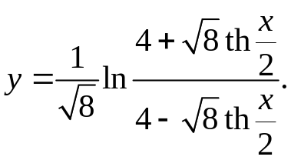
y'= 4-√8th(x/2) * √8(4-√8th(x/2)+4+√8th(x/2)) =
√8(4+√8th(x/2)) 2ch²(x/2)(4-√8th(x/2))²
= 1 _
ch²(x/2)(4-√8th(x/2))
10.20. 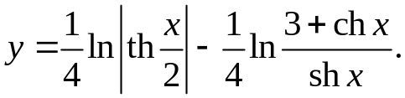
y'= 1 _ shx(sh²x-3chx-ch²x) = 1+chx _
8ch²(x/2)th(x/2) 4sh²x(3+chx) shx(3+chx)
10.21. 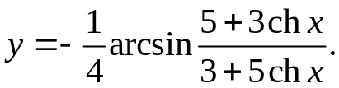
y'= -(3+5chx)(3shx(3+5chx)-5shx(5+3chx)) = 1
4(3+5chx)²√(9+30chx+25ch²x-25-30chx-9ch²x)
10.22. 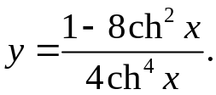
y'= -16ch⁵xshx-4ch³x(1-8ch²x) = -4ch²xshx-1+8ch²x
4ch⁸x ch⁵x
10.23. 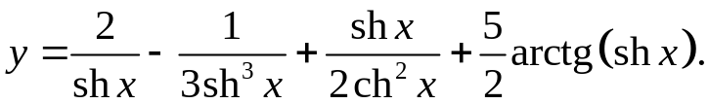
y'= -2/sh²x+1/sh⁴x+ch³x-2chxsh²x+ 5chx = -2/sh²x+1/sh⁴x+1-sh²x+ 5_
2ch⁴x 2+2sh²x 2ch³x 2chx
10.24. 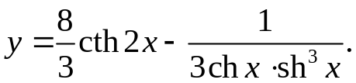
y'= -16 + sh⁴x+3sh²xch²x = 1-4sh²x
3sh²2x 3ch²xsh⁶x ch²xsh⁴x
10.25. 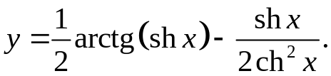
y'= chx _ 1-sh²x = 1 _ 1-sh²x
2+2sh²x 2ch³x 2ch²x 2ch³x
10.26. 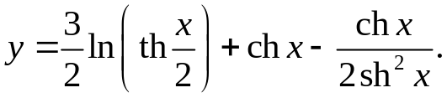
y'= 3 + shx – sh³x-2shxch²x = 1+sh²x
4ch²(x/2)th(x/2) 2sh⁴x shx
10.27. 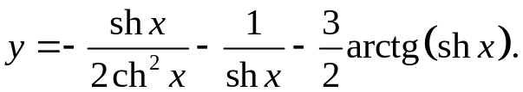
y'= 2chxsh²x-ch³x + 2shxchx _ 3chx = sh²x-1 + 2chx _ 3 _
2ch⁴x sh⁴x 2+2sh²x 2ch³x sh³x 2chx
10.28. 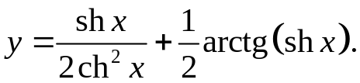
y'= ch³x-2chxsh²x + chx = 1 _
2ch⁴x 2+2sh²x ch³x
10.29. 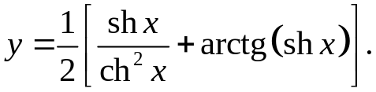
y'= ch³x-2chxsh²x + chx = 1 _
2ch⁴x 2+2sh²x ch³x
10.30. 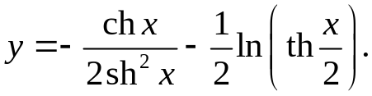
y'= 2ch²xshx-sh³x _ 1 = 1/sh³x
2sh⁴x 4ch²(x/2)th(x/2)
10.31. 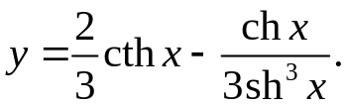
y'= -2 _ sh⁴x-3ch²xsh²x = 1/sh⁴x
3sh²x 3sh⁶x

